Ideation Phase: Empathize & Discover
An employee requests installation of licensed software through the Service Catalog
Date | 31 January 2025
Team ID | SWUID2026190351
Project Name | An employee requests installation of licensed software through the Service Catalog
Maximum Marks | 4 Marks

Empathy Map Canvas Overview
An empathy map is a visual framework that captures key details about a user's behaviors, attitudes, thoughts, and frustrations. To build an effective ServiceNow Automated Software Request Portal, understanding the end-user (Employee) and IT Support Person (Admin) perspectives is critical. The canvas below maps their experiences across Think & Feel, See, Hear, Say & Do, along with Pain points and Gain aspirations.

Project-Specific Empathy Map Diagram
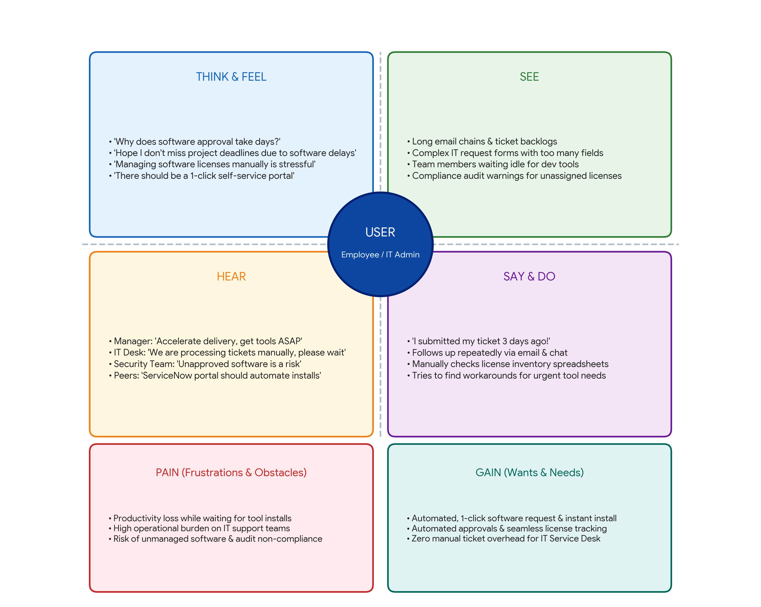

Detailed Empathy Map Canvas Breakdown
Empathy Map Category | User Observations & Insights (ServiceNow Portal Focus)
Think & Feel | • 'Why does software provisioning take days?'  • 'Hope I don't miss project deadlines waiting for software licenses.'  • 'Managing software installation tickets manually is inefficient.'  • 'We need a self-service catalog with automated background installation.'
See | • Long IT support queues and pending email approval threads.  • Multi-step ticket submission forms with redundant data fields.  • Idle developer productivity due to missing software tools.  • Manual license spreadsheets and compliance audit risk warnings.
Hear | • Manager: 'Deliver project milestones on time, get required tools ASAP.'  • IT Desk: 'We are overburdened with manual software installation tickets.'  • Compliance: 'Unapproved software downloads violate security policy.'  • Peers: 'ServiceNow catalog should trigger automatic software deployment.'
Say & Do | • 'I submitted my software request ticket 3 days ago!'  • Frequently follows up with IT support desk via chat and calls.  • Manually verifies available software licenses and user entitlement.  • Explores temporary workarounds while waiting for official approvals.
Pain (Frustrations) | • Significant delay in getting essential project software tools.  • High repetitive operational burden on IT Service Desk administrators.  • Risk of unassigned/untracked software licenses leading to audit fines.
Gain (Wants & Needs) | • 1-click self-service software request portal in ServiceNow.  • Automatic workflow approval & instant silent software installation.  • Complete visibility, license tracking, and automated audit compliance.

